Product Requirements Document
Building Materials Warehouse Management System (BMWMS)
– Report 3

Version | Version 1.0
Date | 01/06/2026

Change Log
Version | Date | Author | Summary
1.0 | 01/06/2026 | Tran Duc Thang | Initial plan

Table of Contents
Change Log 1
Table of Contents 2
1. Business Flows1.1 Overview 4
a. Context Diagram 4
b. Business Flow Index 4
1.2 BF-01: Warehouse Management 5
1.3 BF-02: Storage Location Management 6
1.4 BF-03: Product Location Lookup 6
1.5 BF-04: Warehouse Inventory Monitoring 7
1.6 BF-05: Product Management 8
1.7 BF-06: Product Group Management 9
1.8 BF-07: Product Attribute Management 9
1.9 BF-08: Product Traceability 10
1.10 BF-09: Product Barcode Management 10
2. Conceptual Data Model 11
2.1 Entity Relationship Diagram 11
2.2 Entity List 12
a. Entity: Warehouse 12
b. Entity: Storage Location 12
c. Entity: Inventory 13
d. Entity: Product Group 13
e. Entity: Product 13
f. Entity: Product Attribute 14
g. Entity: Supplier Product 14
h. Entity: Supplier 14
2.3 Data Business Rules 14
3. User Requirements 16
3.1 Actor Definitions 16
3.2 Permission Matrix 16
3.3 Use Case Diagrams 18
a. UCs for Warehouse Manager 18
b. UCs for System Administrator 18
c. UCs for Warehouse Staff 19
d. UCs for Purchasing Staff 20
e. UCs for Sales Staff 20
3.4 Use Case Index 20
4. Functional Requirements 22
4.1 Modules & Features 22
a. Module List 22
b. Module: Warehouse Management 23
c. Module: Product Management 24
x. Won't-Have (This Version) 24
4.2 Screen Inventory 24
a. Screen Flow 24
b. Screen List 25
4.3 External API Inventory 27
4.4 Background Job Inventory 28
5. Global Business Rules 28
5.1 Global Business Rule Table 28
6. Non-Functional Requirements & Constraints 29
6.1 Performance Requirements 29
6.2 Security Requirements 29
6.3 Out of Scope 30
6.4 Technical Assumptions 30

1. Business Flows

1.1 Overview

a. Context Diagram

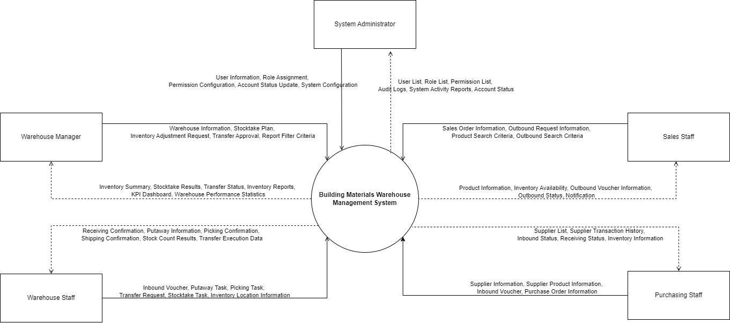

b. Business Flow Index

BF-ID | Flow Name | Primary Actors | Trigger | End Condition
BF-01 | Warehouse Management | Warehouse Manager | A new warehouse needs to be established, or an existing warehouse requires modification to support business operations. | Warehouse information, storage capacity, and operational status are successfully maintained and available for warehouse operations.
BF-02 | Storage Location Management | Warehouse Manager | The warehouse structure needs to be configured or reorganized by defining areas, shelves, bins, or storage capacities. | Storage locations are successfully configured, organized, and ready to receive and store inventory.
BF-03 | Product Management | Warehouse Manager | New products, product groups, or product attributes need to be created or existing product information requires maintenance. | Product master data is complete, validated, and available for inbound, outbound, stocktaking, and reporting processes.
BF-04 | Supplier Management | Purchasing Staff | A new supplier is registered, supplier information changes, or supplied products need to be maintained. | Supplier information and supplier-product relationships are successfully maintained and available for procurement and receiving activities.
BF-05 | Inbound Management | Purchasing Staff, Warehouse Staff, Warehouse Manager | Goods are expected to arrive at the warehouse and an inbound order is created for receiving operations. | Goods are received, verified, assigned to appropriate storage locations, inventory quantities are updated, and inbound transactions are completed successfully.
BF-06 | Outbound Management | Sales Staff, Warehouse Staff, Warehouse Manager | An outbound request is created to fulfill customer demand or internal material requirements. | Inventory availability is verified, goods are picked and shipped, inventory balances are updated, and outbound transactions are completed successfully.
BF-07 | Inventory Management | Warehouse Manager, Warehouse Staff | Inventory verification, stock adjustment, or warehouse transfer activities are required to maintain inventory accuracy. | Stocktaking results are recorded, discrepancies are resolved, warehouse transfers are completed, and inventory records accurately reflect physical stock.
BF-08 | Reporting and Analytics | Warehouse Manager | Operational reports, inventory analysis, warehouse performance, or business statistics are requested for monitoring and decision-making. | Required reports, dashboards, and statistical analyses are generated and presented with up-to-date warehouse information.
BF-09 | User and Security Management | System Administrator, All Users | A user needs to access the system, update account information, or an administrator needs to manage users and access permissions. | User authentication, account management, role assignment, and system access permissions are successfully maintained according to security policies.

1.2 BF-01: Warehouse Management
Primary Actor: Warehouse Manager
Related Use Cases: UC01, UC02, UC03, UC04, UC05
Trigger: Warehouse Manager needs to create a new warehouse, update warehouse information, review warehouse details, or deactivate a warehouse to support warehouse operations.
End Condition: Warehouse information is successfully maintained in the system and is available for inventory, inbound, outbound, stocktaking, and warehouse transfer operations.

Step | Actor | Action | UC-ID
1 | Warehouse Manager | Accesses the Warehouse List screen. | → UC01
2 | System | Displays the list of warehouses with summary information. | → UC01
3 | Warehouse Manager | Searches or filters warehouses by Warehouse Code, Warehouse Name, Address, Status, or other search criteria. | → UC01
4 | System | Displays the filtered warehouse list. | → UC01
5 | Warehouse Manager | Selects Create Warehouse to register a new warehouse. | → UC02
6 | System | Displays the warehouse creation form. | → UC02
7 | Warehouse Manager | Enters warehouse information, including warehouse code, warehouse name, address, contact information, warehouse manager, capacity, and operational status. | → UC02
8 | Warehouse Manager | Submits the warehouse information. | → UC02
9 | System | Validates mandatory fields, warehouse code uniqueness, and business rules. | → UC02
10 | System | Creates the warehouse record and stores it in the database. | → UC02
11 | System | Displays the Warehouse Detail screen for the newly created warehouse. | → UC04
12 | Warehouse Manager | Reviews warehouse information. | → UC04
13 | Warehouse Manager | Selects Edit Warehouse when warehouse information needs to be updated. | → UC03
14 | System | Displays the warehouse editing form. | → UC03
15 | Warehouse Manager | Updates warehouse information and submits the changes. | → UC03
16 | System | Validates the updated information. | → UC03
17 | System | Updates the warehouse information successfully and displays the latest warehouse details. | → UC03
18 | Warehouse Manager | Selects Deactivate Warehouse when the warehouse is no longer used. | → UC05
19 | System | Verifies whether the warehouse can be deactivated according to business rules. | → UC05
20 | System | Changes the warehouse status to Inactive and removes it from active warehouse operations. | → UC05
Exception Paths
Step | Exception
7 | Required information is missing.
8 | Warehouse Manager cancels the operation before submitting.
9 | Warehouse Code already exists.
9 | Invalid warehouse information (invalid capacity, invalid contact information, etc.).
15 | Updated information violates validation rules.
18 | Warehouse Manager cancels the deactivation request.
19 | The warehouse still contains inventory.
19 | The warehouse contains active storage locations.
19 | The warehouse has pending inbound, outbound, stocktaking, or transfer transactions.
20 | System fails to update the warehouse status due to an unexpected system error.
Related Use Cases
UC-ID | Use Case
UC01 | View Warehouse List
UC02 | Create Warehouse
UC03 | Update Warehouse
UC04 | View Warehouse Detail
UC05 | Deactivate Warehouse

1.3 BF-02: Storage Location Management
Trigger: Warehouse Manager needs to configure storage locations within a warehouse.
End condition: Storage locations are successfully created, updated, or maintained.

Step | Actor | Action | UC-ID
1 | Warehouse Manager | Opens Warehouse Detail | → UC04
2 | Warehouse Manager | Navigates to Storage Locations | → UC06
3 | Warehouse Manager | Reviews existing storage locations | → UC06
4 | Warehouse Manager | Creates a new storage location | → UC07
5 | Warehouse Manager | Enters location information (Zone, Rack, Shelf, Bin, Capacity) | → UC07
6 | System | Creates the storage location | → UC07
7 | Warehouse Manager | Views storage location details | → UC09
8 | Warehouse Manager | Updates storage location information | → UC08
9 | System | Saves updated storage location information | → UC08
Exception Paths
Step 5: Location code already exists → Creation is rejected.
Step 5: Capacity value is invalid → Validation error is displayed.
Step 8: Location contains active inventory and update violates business rules → Update is rejected.

1.4 BF-03: Product Location Lookup
Trigger: Warehouse staff needs to locate a product within the warehouse.
End condition: Product storage location is identified and displayed.

Step | Actor | Action | UC-ID
1 | Warehouse Staff | Accesses Inventory List | → UC10
2 | Warehouse Staff | Searches inventory by product code, product name, or storage location | → UC10
3 | System | Displays matching inventory records | → UC10
4 | Warehouse Staff | Selects a product from the inventory list | → UC10
5 | System | Displays Product Inventory Detail | → UC10
6 | Warehouse Staff | Reviews storage location information | → UC10
7 | Warehouse Staff | Opens location map or layout information | → UC10
Exception Paths
Step 2: Product does not exist → No records found.
Step 3: Product exists but inventory quantity is zero → Product information is displayed with zero stock.
Step 7: Location layout is unavailable → System displays location code only.

1.5 BF-04: Warehouse Inventory Monitoring
Trigger: Warehouse Manager needs to review inventory levels and inventory movements within a warehouse.
End condition: Inventory status and transaction history are successfully reviewed.

Step | Actor | Action | UC-ID
1 | Warehouse Manager | Opens Warehouse Detail | → UC04
2 | Warehouse Manager | Navigates to Inventory | → UC10
3 | System | Displays inventory information for the selected warehouse | → UC10
4 | Warehouse Manager | Filters inventory by product, group, location, or status | → UC10
5 | Warehouse Manager | Selects a product inventory record | → UC10
6 | System | Displays Product Inventory Detail | → UC10
7 | Warehouse Manager | Reviews stock quantity, reserved quantity, and available quantity | → UC10
8 | Warehouse Manager | Reviews transaction history of the selected product | → UC10
9 | Warehouse Manager | Opens Warehouse Transactions | → UC10
10 | Warehouse Manager | Filters and reviews inventory movement history | → UC10
11 | Warehouse Manager | Exports inventory or transaction data | → UC10
Exception Paths
Step 4: No inventory matches the search criteria → Empty result is displayed.
Step 8: Product has no transaction history → Empty history is displayed.
Step 11: Export process fails → System displays export error message.

1.6 BF-05: Product Management
Trigger: Warehouse Manager needs to create, update, view, or deactivate a product.
End condition: Product information is successfully maintained in the system.

Step | Actor | Action | UC-ID
1 | Warehouse Manager | Accesses the Product List screen | → UC11
2 | Warehouse Manager | Searches or filters products | → UC11
3 | Warehouse Manager | Selects Create Product | → UC12
4 | Warehouse Manager | Enters product information | → UC12
5 | Warehouse Manager | Assigns a product group | → UC12, UC16
6 | Warehouse Manager | Configures product attributes | → UC20
7 | Warehouse Manager | Saves the product | → UC12
8 | System | Validates and creates the product | → UC12
9 | Warehouse Manager | Views product details | → UC14
10 | Warehouse Manager | Updates product information when required | → UC13
11 | System | Saves updated product information | → UC13
Exception Paths
Step 4: Required information is missing → Validation error displayed.
Step 8: Product code already exists → Product creation is rejected.
Step 10: Product has historical transactions and cannot be deleted → Only deactivation is allowed (UC15).

1.7 BF-06: Product Group Management
Trigger: Warehouse Manager needs to create or maintain product groups.
End condition: Product group information is successfully maintained.

Step | Actor | Action | UC-ID
1 | Warehouse Manager | Accesses Product Group List | → UC16
2 | Warehouse Manager | Reviews existing product groups | → UC16
3 | Warehouse Manager | Selects Create Product Group | → UC17
4 | Warehouse Manager | Enters product group information | → UC17
5 | Warehouse Manager | Saves the product group | → UC17
6 | System | Creates the product group | → UC17
7 | Warehouse Manager | Updates product group information | → UC18
8 | System | Saves updated product group information | → UC18
9 | Warehouse Manager | Assigns products to the product group | → UC12, UC13
Exception Paths
Step 4: Group code already exists → Creation is rejected.
Step 7: Product group contains active products → Deletion is not allowed.
Step 9: Product already belongs to another restricted group → Assignment is rejected.

1.8 BF-07: Product Attribute Management
Trigger: Warehouse Manager needs to configure product attributes.
End condition: Product attributes are successfully configured and available for products.

Step | Actor | Action | UC-ID
1 | Warehouse Manager | Accesses Product Attribute List | → UC19
2 | Warehouse Manager | Reviews available attributes | → UC19
3 | Warehouse Manager | Creates a new attribute | → UC20
4 | Warehouse Manager | Defines attribute information and data type | → UC20
5 | Warehouse Manager | Defines selectable values if required | → UC20
6 | Warehouse Manager | Saves the attribute configuration | → UC20
7 | System | Creates the attribute successfully | → UC20
8 | Warehouse Manager | Assigns attributes to products | → UC12, UC13
Exception Paths
Step 4: Attribute name already exists → Creation is rejected.
Step 5: Attribute value format is invalid → Validation error displayed.
Step 8: Product is inactive → Attribute assignment is not allowed.

1.9 BF-08: Product Traceability
Trigger: Warehouse Manager or Warehouse Staff needs to review product movement history.
End condition: Product traceability information is displayed successfully.

Step | Actor | Action | UC-ID
1 | Warehouse Manager / Warehouse Staff | Accesses Product List | → UC11
2 | Warehouse Manager / Warehouse Staff | Searches for a product | → UC11
3 | Warehouse Manager / Warehouse Staff | Opens Product Detail | → UC14
4 | Warehouse Manager / Warehouse Staff | Selects Product History | → UC21
5 | System | Retrieves inventory transaction history | → UC21
6 | System | Displays inbound, outbound, transfer, and adjustment history | → UC21
7 | Warehouse Manager / Warehouse Staff | Reviews movement records and inventory changes | → UC21
Exception Paths
Step 2: Product does not exist → No records found.
Step 5: Product has no inventory transactions → Empty history displayed.
Step 6: Historical records exceed query limits → System applies pagination.

1.10 BF-09: Product Barcode Management
Trigger: Warehouse Manager needs to create or maintain product barcodes.
End condition: Product barcode information is successfully maintained.

Step | Actor | Action | UC-ID
1 | Warehouse Manager | Opens Product Detail | → UC14
2 | Warehouse Manager | Accesses Barcode Management section | → UC14
3 | Warehouse Manager | Creates or assigns a barcode | → UC12, UC13
4 | Warehouse Manager | Enters barcode information | → UC12, UC13
5 | System | Validates barcode uniqueness | → UC12, UC13
6 | System | Saves barcode information | → UC12, UC13
7 | Warehouse Manager | Uses barcode to search or identify products | → UC11
Exception Paths
Step 4: Barcode format is invalid → Validation error displayed.
Step 5: Barcode already exists in the system → Barcode assignment is rejected.
Step 7: Barcode is not found → Product lookup fails and no results are returned.

2. Conceptual Data Model

2.1 Entity Relationship Diagram

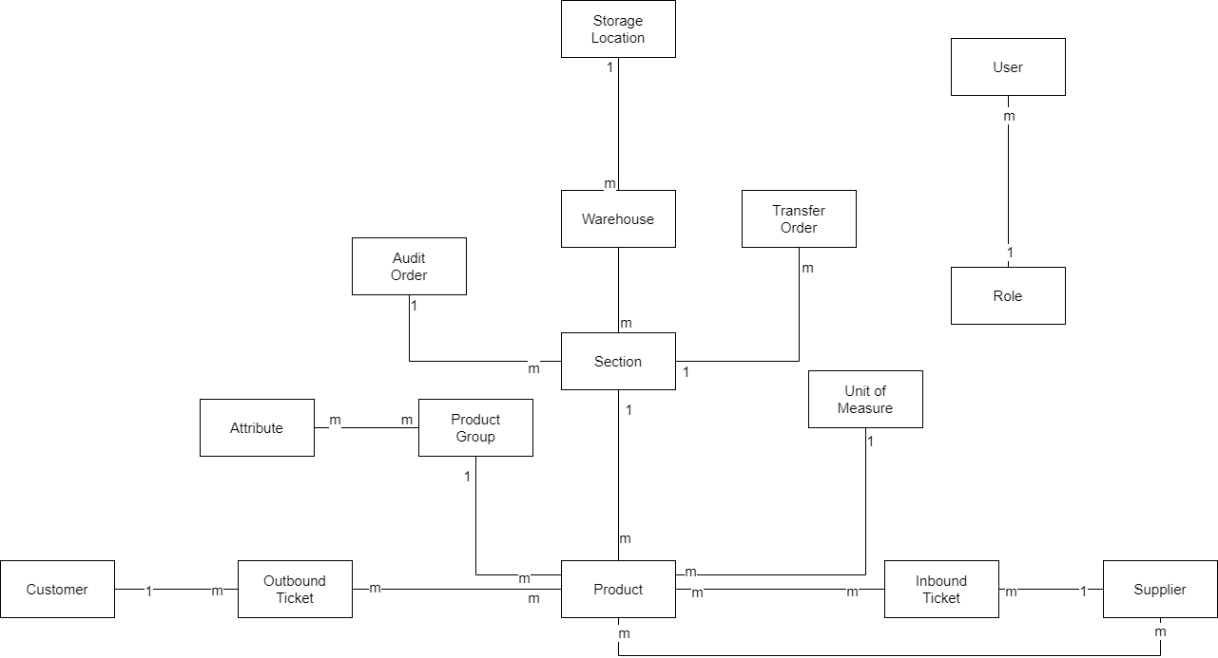

2.2 Entity List

a. Entity: Warehouse
Field | Value
Purpose | Represents a physical warehouse where products are stored and managed.
Key business attributes | Warehouse code, warehouse name, address, status.
Business identity | Warehouse code must be unique across the system.
Status / lifecycle | Active → Inactive.
FT-ID ref | F01.01 – Warehouse Management

b. Entity: Storage Location
Field | Value
Purpose | Represents a storage area, shelf, rack, or bin within a warehouse.
Key business attributes | Location code, location name, location type, capacity, status.
Business identity | Location code must be unique within a warehouse.
Status / lifecycle | Active → Inactive.
FT-ID ref | F01.02 – Storage Location Management

c. Entity: Inventory
Field | Value
Purpose | Represents the current stock quantity of a product at a specific storage location.
Key business attributes | Quantity, reserved quantity, available quantity, last updated date.
Business identity | Each inventory record is uniquely identified by a product and storage location combination.
Status / lifecycle | Available → Reserved → Adjusted.
FT-ID ref | F01.03 – Product Location Tracking

d. Entity: Product Group
Field | Value
Purpose | Represents a category used to organize products.
Key business attributes | Group code, group name, description, status.
Business identity | Group code must be unique across the system.
Status / lifecycle | Active → Inactive.
FT-ID ref | F02.02 – Product Group Management

e. Entity: Product
Field | Value
Purpose | Represents a product or material managed within the warehouse.
Key business attributes | Product code, product name, SKU, barcode, brand, origin country, unit of measure, status.
Business identity | Product code and barcode must be unique across the system.
Status / lifecycle | Active → Inactive.
FT-ID ref | F02.01 – Product Management

f. Entity: Product Attribute
Field | Value
Purpose | Represents configurable attributes that can be assigned to products.
Key business attributes | Attribute code, attribute name, data type, required flag, status.
Business identity | Attribute code must be unique across the system.
Status / lifecycle | Active → Inactive.
FT-ID ref | F02.03 – Product Attribute Management

g. Entity: Supplier Product
Field | Value
Purpose | Represents a supplier that provides products or materials to the warehouse.
Key business attributes | Supplier code, supplier name, contact person, phone, email, address, status.
Business identity | Supplier code and supplier email must be unique across the system.
Status / lifecycle | Active → Inactive.
FT-ID ref | F03.01 – Supplier Management

h. Entity: Supplier
Field | Value
Purpose | Represents the relationship between suppliers and products they provide.
Key business attributes | Supplier, product, lead time, preferred supplier flag.
Business identity | One supplier can only be linked once to the same product.
Status / lifecycle | Active → Inactive.
FT-ID ref | F03.02 – Supplier Product Management

2.3 Data Business Rules
Rules about data that are not obvious from the ERD. Plain language — implementation details in TDS.

Rule | Description | Enforced On
Unique warehouse code | No two warehouses may share the same warehouse code. | Warehouse creation and update
Warehouse cannot be deleted | Warehouses are deactivated instead of permanently deleted to preserve inventory history. | Warehouse deactivation
Location code unique within warehouse | No two storage locations in the same warehouse may share the same location code. | Storage location creation and update
Storage location with inventory cannot be deactivated | A storage location containing inventory cannot be deactivated until all stock is removed. | Storage location deactivation
Product code unique | No two products may share the same product code. | Product creation and update
Barcode unique | A barcode may belong to only one product across the entire system. | Product creation and update
Product belongs to one group | Every product must belong to exactly one Product Group. | Product creation and update
Product group cannot be deleted if used | A Product Group assigned to at least one Product cannot be deleted. It must be deactivated instead. | Product group deactivation
Product cannot be deleted | Products are deactivated rather than permanently deleted to preserve transaction history. | Product deactivation
Attribute name unique | No two Product Attributes may share the same attribute name. | Attribute creation and update
Attribute type immutable after use | Once an attribute is assigned to any product, its data type cannot be changed. | Attribute update
Inventory record unique | Only one inventory record may exist for a Product at a specific Storage Location. | Inventory update
Inventory quantity cannot be negative | Available inventory quantity must never fall below zero. | Inventory transactions
Reserved quantity cannot exceed stock | Reserved quantity must not exceed current inventory quantity. | Inventory reservation
Product location traceability required | Every inventory movement must be traceable to a warehouse and storage location. | Inventory transactions
Product must have active status before stocking | Only active products may be received, stored, transferred, or issued. | Inventory operations
Warehouse must have at least one location | A warehouse cannot become operational without at least one active storage location. | Warehouse activation
Product group hierarchy cannot be circular | A product group cannot be assigned as its own parent, directly or indirectly. | Product group configuration
Attribute value must match data type | Product attribute values must conform to the configured attribute data type. | Product maintenance
Inventory changes require transaction history | Every inventory quantity change must generate an inventory transaction record. | Inventory update

3. User Requirements
Purpose
Single source of truth for all access decisions. Every UC 'Allowed Roles' and TDS security configuration must be consistent with the permission matrix below.

Guidance
Define actor names here first — copy verbatim into UCS and TDS (exact case/spacing). Permission matrix rows are Entity × Action, derived from §4 entities. Explain every 'Restricted' entry in a footnote.

3.1 Actor Definitions
Actor | Description | Sign-in Required | Notes
System Administrator | Manages user accounts, roles, permissions, system settings, and security configurations | Yes | Created during initial system setup
Warehouse Manager | Oversees warehouse operations, manages warehouses, inventory, stocktaking, transfers, and reports | Yes | Created by System Administrator
Warehouse Staff | Performs daily warehouse operations including receiving, issuing, transferring, and counting inventory | Yes | Assigned to one or more warehouses
Purchasing Staff | Creates and manages purchase orders and inbound requests from suppliers | Yes | Created by System Administrator

Role hierarchy: System Administrator has access to system configuration and user management functions. No other role inheritance applies.

3.2 Permission Matrix
Full = unrestricted · Restricted = conditions apply (see footnotes) · No = denied

Entity | Action | System Administrator | Warehouse Manager | Warehouse Staff | Purchasing Staff | Sales Staff
Warehouse | Create | Full | Full | No | No | No
Warehouse | View | Full | Full | Full | View | View
Warehouse | Edit | Full | Full | No | No | No
Warehouse | Deactivate | Full | Full | No | No | No
Warehouse | Duplicate | Full | Full | No | No | No
Storage Location | Create | Full | Full | No | No | No
Storage Location | View | Full | Full | Full | View | View
Storage Location | Edit | Full | Full | Restricted¹ | No | No
Storage Location | Deactivate | Full | Full | No | No | No
Inventory | View | Full | Full | Full | View | View
Inventory | Export | Full | Full | Restricted² | No | No
Product | Create | Full | Full | No | No | No
Product | View | Full | Full | Full | Full | Full
Product | Edit | Full | Full | No | No | No
Product | Deactivate | Full | Full | No | No | No
Product Group | Create | Full | Full | No | No | No
Product Group | View | Full | Full | Full | Full | Full
Product Group | Edit | Full | Full | No | No | No
Product Attribute | Create | Full | Full | No | No | No
Product Attribute | View | Full | Full | Full | Full | Full
Product Attribute | Edit | Full | Full | No | No | No
Product History | View | Full | Full | Full | View | View
Product Barcode | Create | Full | Full | No | No | No
Product Barcode | View | Full | Full | Full | Full | Full
Product Barcode | Edit | Full | Full | No | No | No

¹ Warehouse Staff – Edit Storage Location (Restricted):
Warehouse Staff may update temporary operational information (e.g., occupancy status) but cannot modify location structure, capacity, zone, rack, shelf, or bin definitions.
² Warehouse Staff – Export Inventory (Restricted):
Warehouse Staff may export inventory data only for warehouses assigned to them. Export of system-wide inventory data is not permitted.

3.3 Use Case Diagrams
This section contains Use Case Diagrams for Iteration 1, covering only the functionalities implemented in Module 1 – Warehouse Management and Module 2 – Product Management. Use cases belonging to subsequent iterations are excluded and will be documented in later releases.

a. UCs for Warehouse Manager
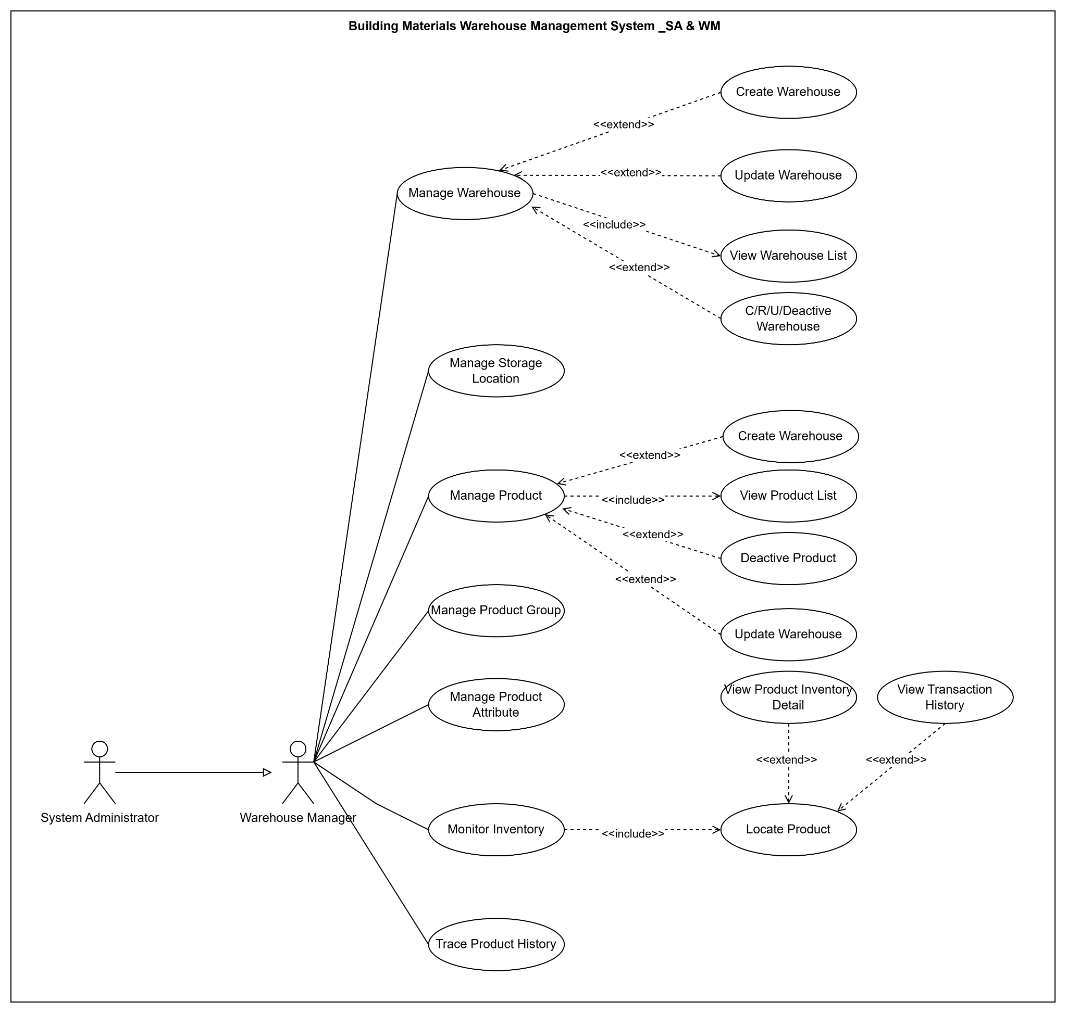

b. UCs for System Administrator

System Administrator inherits all permissions granted to Warehouse Manager for support and administration purposes.

c. UCs for Warehouse Staff
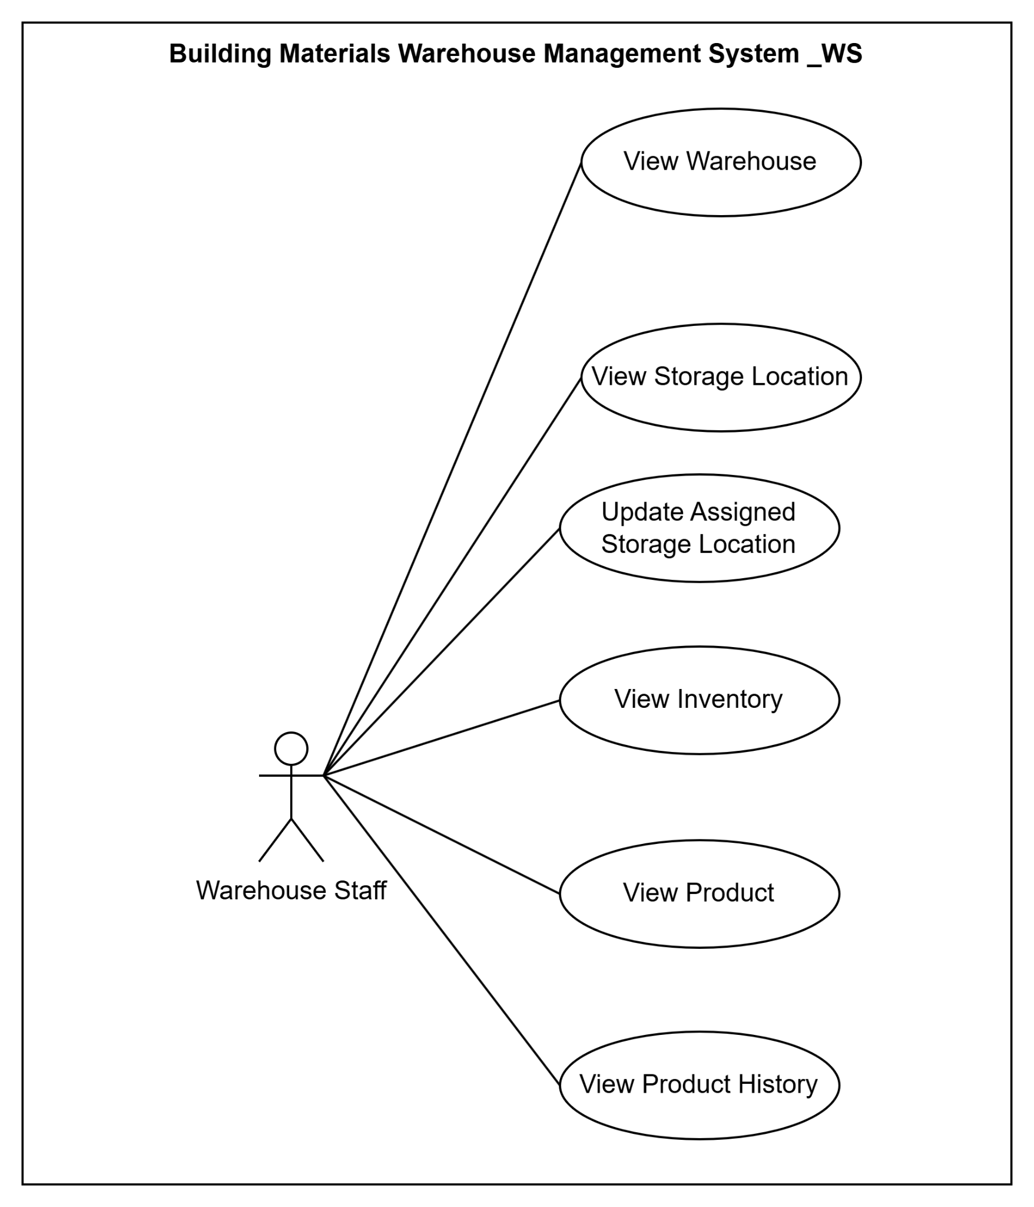

d. UCs for Purchasing Staff
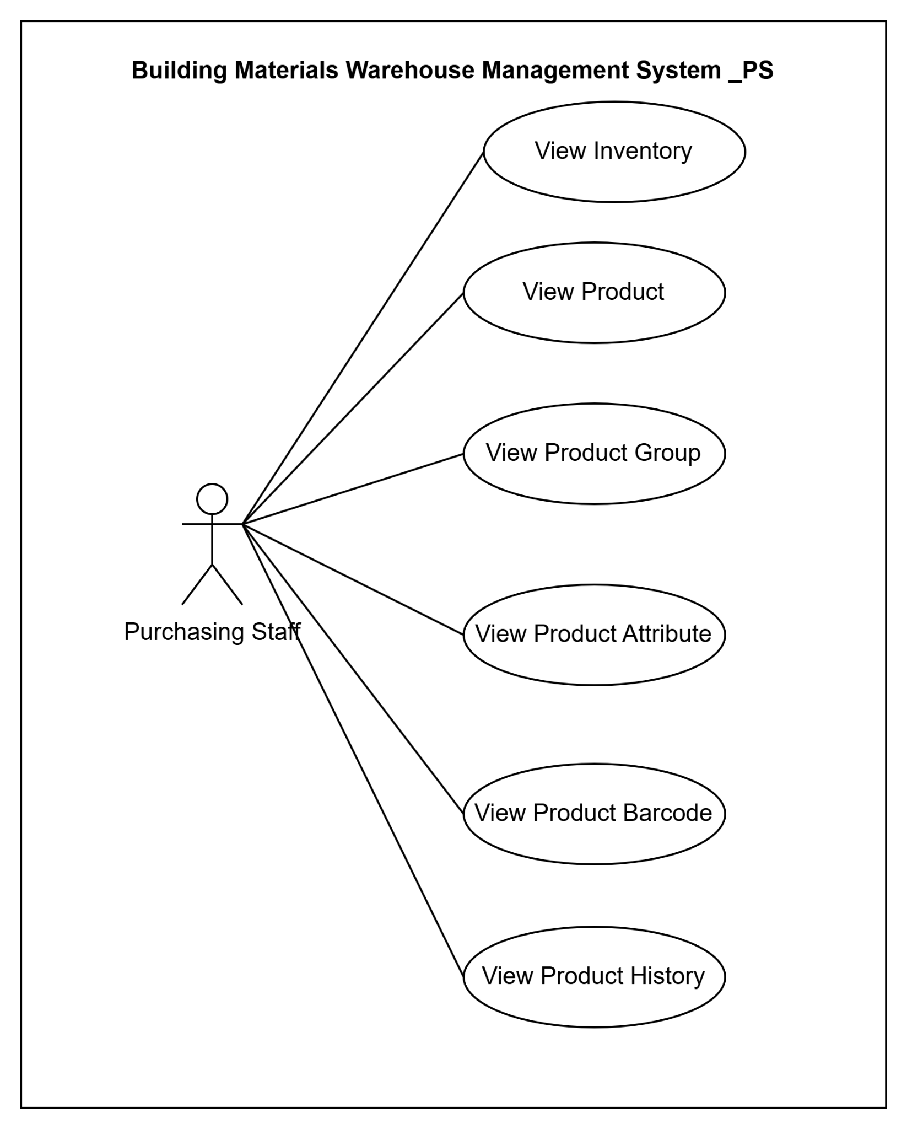

e. UCs for Sales Staff
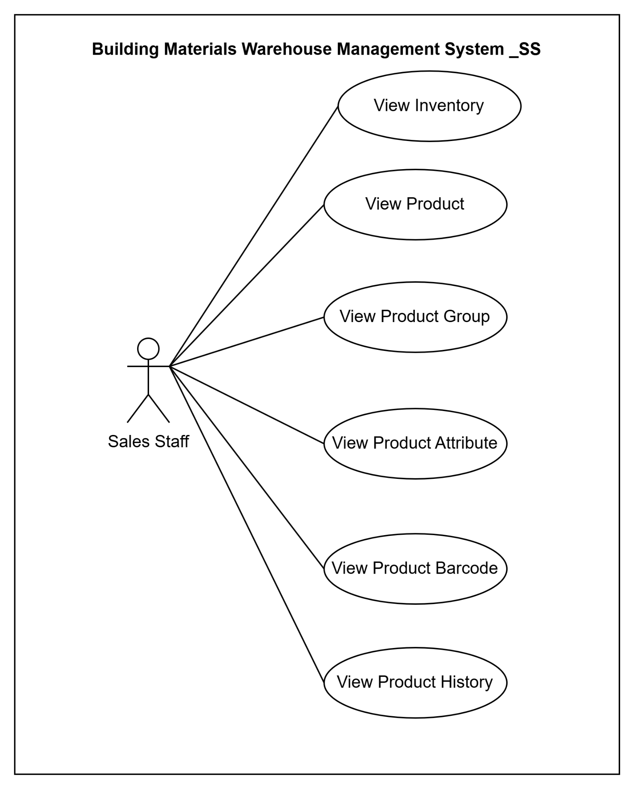

3.4 Use Case Index
UC-ID | Use Case Name | Type | Primary Actor | Description
UC-01 | Manage Warehouses | UI | Warehouse Manager | Create, view, update, duplicate, and deactivate warehouse records, including warehouse profile information, operational status, and assigned warehouse manager.
UC-02 | View Warehouse Details | UI | Warehouse Manager | View detailed warehouse information including address, manager, capacity overview, storage locations, inventory summary, and warehouse-related activities.
UC-03 | Manage Storage Locations | UI | Warehouse Manager | Create, update, deactivate, and organize storage locations such as zones, racks, shelves, bins, and other warehouse structures.
UC-04 | View Storage Location Details | UI | Warehouse Manager | View detailed information about a storage location, including hierarchy, capacity, utilization, and assigned inventory.
UC-05 | Monitor Inventory | UI | Warehouse Manager | Monitor inventory quantities across warehouses and storage locations, including stock availability, reserved stock, and inventory status.
UC-06 | View Inventory Details | UI | Warehouse Manager | View inventory information for a specific product and location, including stock balance, transaction history, and location movement history.
UC-07 | Locate Products | UI | Warehouse Manager | Search and identify the exact storage location of products within the warehouse structure for operational and inventory control purposes.
UC-08 | View Warehouse Transactions | UI | Warehouse Manager | Review warehouse transaction history including inbound, outbound, transfer, and stock adjustment activities.
UC-09 | Export Warehouse Data | UI | Warehouse Manager | Export warehouse, storage location, inventory, and transaction information to Excel or other supported formats for reporting purposes.
UC-10 | Manage Products | UI | Warehouse Manager | Create, view, update, and deactivate products while maintaining product master information and operational status.
UC-11 | View Product Details | UI | Warehouse Manager | View detailed product information including specifications, attributes, barcode information, inventory status, and related history.
UC-12 | Manage Product Groups | UI | Warehouse Manager | Create, update, and maintain product group structures used for product classification and reporting.
UC-13 | Manage Product Attributes | UI | Warehouse Manager | Configure product attributes and attribute values used to define product characteristics and classifications.
UC-14 | Manage Product Barcodes | UI | Warehouse Manager | Create, update, and maintain barcode information used for product identification and warehouse operations.
UC-15 | Trace Product History | UI | Warehouse Manager | View complete product lifecycle history, including inventory movements, warehouse transactions, and stock adjustments.
UC-16 | Search Products | UI | Warehouse Staff | Search and view products using product code, name, barcode, category, or inventory-related criteria.
UC-17 | View Inventory Information | UI | Warehouse Staff | View inventory balances, storage locations, and product availability based on assigned warehouse permissions.
UC-18 | View Product Information | UI | Purchasing Staff | Review product specifications, inventory availability, and product history to support procurement activities.
UC-19 | View Inventory Availability | UI | Sales Staff | Check current inventory availability and product locations to support sales planning and fulfillment activities.
UC-20 | Manage System Configuration | UI | System Administrator | Configure system parameters, user permissions, role assignments, and other administrative settings required for warehouse operations.

4. Functional Requirements
Guidance
FT-IDs are sequential from FT-01 and immutable — never renumber. Priority: Must (blocking) / Should / Could / Won't. Feature name: verb + noun. One feature may map to multiple UCs.

4.1 Modules & Features

a. Module List
Module | Purpose | Primary Actor(s)
Warehouse Management | Manage warehouses, storage locations, warehouse structure, product locations, and inventory visibility across warehouses. | System Administrator, Warehouse Manager, Warehouse Staff
Product Management | Manage product master data, product groups, attributes, barcodes, and product traceability information. | System Administrator, Warehouse Manager
Supplier Management | Manage supplier information, supplied products, and supplier transaction history. | System Administrator, Warehouse Manager, Purchasing Staff
Inbound Management | Manage inbound orders, receiving operations, inventory updates, and storage location assignment. | Warehouse Manager, Warehouse Staff, Purchasing Staff
Outbound Management | Manage outbound orders, stock allocation, picking, issuing goods, and outbound tracking. | Warehouse Manager, Warehouse Staff, Sales Staff
Stock Taking Management | Plan stock audits, perform counting activities, record discrepancies, and adjust inventory. | Warehouse Manager, Warehouse Staff
Warehouse Transfer Management | Manage transfer requests and execute inventory transfers within or between warehouses. | Warehouse Manager, Warehouse Staff
Reporting & Analytics | Provide inventory reports, inbound/outbound reports, warehouse analytics, supplier statistics, and export capabilities. | Warehouse Manager, Purchasing Staff, Sales Staff
User Management | Manage user accounts, user profiles, account status, and role assignments. | System Administrator
Authentication & Security | Manage authentication, password management, session control, and account security. | All
Dashboard & Notifications | Provide operational dashboards, KPI monitoring, low-stock alerts, task notifications, and system alerts. | System Administrator, Warehouse Manager, Warehouse Staff

b. Module: Warehouse Management
FT-ID | Feature | Priority | Description | UC-ID Ref | BF-ID Ref
FT-01 | Manage Warehouse | Must | Allow users to create, view, update, duplicate, and deactivate warehouse records including warehouse code, name, address, manager, and operational status. | UC-01, UC-02, UC-03, UC-04, UC-05 | BF-01
FT-02 | Manage Storage Location | Must | Allow users to create, view, update, and deactivate storage locations including Zone, Rack, Shelf, Bin, capacity, and status within a warehouse. | UC-06, UC-07, UC-08, UC-09 | BF-02
FT-03 | Locate Product | Must | Allow users to search and identify the current storage location of a product within a warehouse structure. | UC-10 | BF-03
FT-04 | Monitor Warehouse Inventory | Must | Allow users to view inventory levels, stock status, warehouse transactions, and inventory details by warehouse and storage location. | UC-11, UC-12, UC-13 | BF-04

c. Module: Product Management
FT-ID | Feature | Priority | Description | UC-ID Ref | BF-ID Ref
FT-05 | Manage Product | Must | Allow users to create, view, update, and deactivate products including product code, name, group, unit of measure, and product information. | UC-14, UC-15, UC-16, UC-17 | BF-05
FT-06 | Manage Product Group | Must | Allow users to create, view, and maintain product group structures used for product classification and reporting. | UC-18, UC-19, UC-20 | BF-06
FT-07 | Manage Product Attribute | Must | Allow users to define, update, and maintain product attributes and attribute values for product specifications. | UC-21, UC-22, UC-23 | BF-07
FT-08 | View Product Traceability | Must | Allow users to review product inventory movement history, inbound transactions, outbound transactions, transfer history, and stock adjustments. | UC-24 | BF-08
FT-09 | Manage Product Barcode | Should | Allow users to generate, assign, view, and maintain barcode information associated with products. | UC-25, UC-26, UC-27 | BF-09

x. Won't-Have (This Version)
Explicitly exclude features to prevent scope creep and tell Claude Code what NOT to implement.
- AI-assisted CV screening or job description generation
- Email or SMS notifications to candidates or interviewers
- Single sign-on (SSO) or third-party login
- Native mobile application
- Multi-language support
- Export in PDF format
- Integration with external job boards or HR management systems

4.2 Screen Inventory

a. Screen Flow
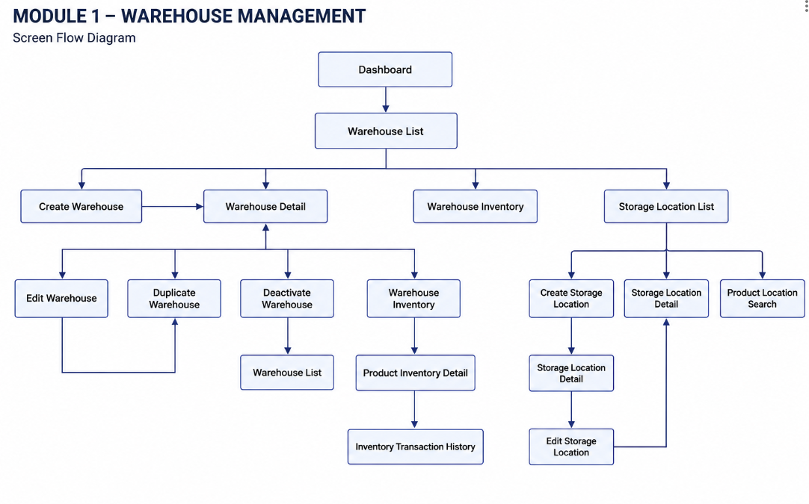
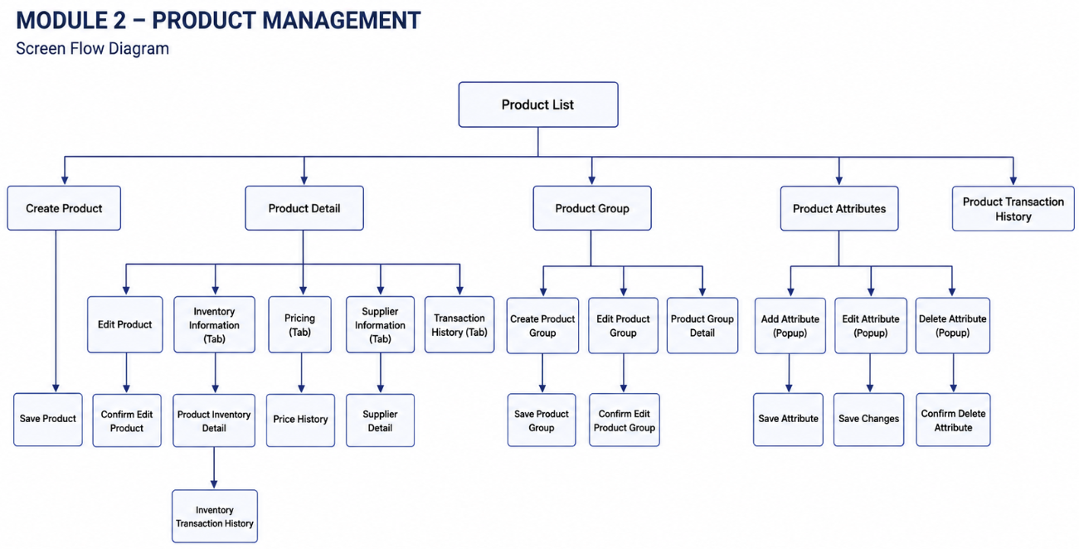

b. Screen List
Fill details of each screen into the table with the columns and sample data as below
SCR-ID | Screen Name | Module | Description | FT-ID | UC-ID
SCR-01 | Warehouse List | Warehouse Management | Display warehouse list with search and filter functions. | FT-01 | UC01
SCR-02 | Create Warehouse | Warehouse Management | Allow users to create a new warehouse. | FT-01 | UC02
SCR-03 | Edit Warehouse | Warehouse Management | Allow users to update warehouse information. | FT-01 | UC03
SCR-04 | Warehouse Detail | Warehouse Management | Display detailed information of a warehouse. | FT-01 | UC04
SCR-05 | Deactivate Warehouse Popup | Warehouse Management | Confirm warehouse deactivation action. | FT-01 | UC05
SCR-06 | Duplicate Warehouse | Warehouse Management | Create a new warehouse based on an existing warehouse. | FT-01 | UC02
SCR-07 | Storage Location List | Warehouse Management | Display storage locations belonging to a selected warehouse. | FT-02 | UC06
SCR-08 | Create Storage Location | Warehouse Management | Allow users to create a new storage location. | FT-02 | UC07
SCR-09 | Edit Storage Location | Warehouse Management | Allow users to update storage location information. | FT-02 | UC08
SCR-10 | Storage Location Detail | Warehouse Management | Display detailed information of a storage location. | FT-02 | UC09
SCR-11 | Product Location Search | Warehouse Management | Allow users to locate products inside warehouses. | FT-03 | UC10
SCR-12 | Warehouse Inventory | Warehouse Management | Display inventory quantities and stock status within a warehouse. | FT-04 | UC04
SCR-13 | Product Inventory Detail | Warehouse Management | Display detailed inventory information of a selected product. | FT-04 | UC04
SCR-14 | Warehouse Transaction History | Warehouse Management | Display inventory movement history of warehouse products. | FT-04 | UC04
SCR-15 | Product List | Product Management | Display product list with search, filter and management actions. | F02.01 | UC11
SCR-16 | Create Product | Product Management | Create a new product master record. | F02.01 | UC12
SCR-17 | Edit Product | Product Management | Update product information. | F02.01 | UC13
SCR-18 | Product Detail | Product Management | Display detailed product information. | F02.01 | UC14
SCR-19 | Deactivate Product Popup | Product Management | Confirm product deactivation. | F02.01 | UC15
SCR-20 | Duplicate Product | Product Management | Create a copy of an existing product. | F02.01 | UC12
SCR-21 | Product Group List | Product Management | Display product groups. | F02.02 | UC16
SCR-22 | Create Product Group | Product Management | Create a new product group. | F02.02 | UC17
SCR-23 | Edit Product Group | Product Management | Update product group information. | F02.02 | UC18
SCR-24 | Product Attribute List | Product Management | Display all product attributes. | F02.03 | UC19
SCR-25 | Create Product Attribute | Product Management | Create a new product attribute. | F02.03 | UC20
SCR-26 | Edit Product Attribute | Product Management | Update attribute configuration. | F02.03 | UC20
SCR-27 | Add Dropdown Options | Product Management | Configure dropdown attribute values. | F02.03 | UC20
SCR-28 | Assign Product Attribute | Product Management | Assign master attributes to a product. | F02.03 | UC20
SCR-29 | Product Transaction History | Product Management | View product transaction history. | F02.04 | UC21
SCR-30 | Product Detail – Basic Information | Product Management | View product basic information tab. | F02.01 | UC14
SCR-31 | Product Detail – Inventory Information | Product Management | View inventory information of product. | F02.04 | UC21
SCR-32 | Product Detail – Pricing | Product Management | View pricing information of product. | F02.01 | UC14
SCR-33 | Product Detail – Supplier Information | Product Management | View suppliers linked to product. | F02.01 | UC14
SCR-34 | Product Detail – Product Attributes | Product Management | View assigned attributes of product. | F02.03 | UC20
SCR-35 | Product Detail – Transaction History | Product Management | View product movement history. | F02.04 | UC21

4.3 External API Inventory
Fill details of each external API into the table with the columns and sample data as below
API-ID | API Name | Calling Path | Description
API-01 | Employee sync API | HRM System → TalentHub | allows an external HR management system to push employee records and automatically create Interviewer accounts
API-02 | Outbound webhook | TalentHub → External HRM | notifies an external system when a Candidate's status changes to HIRED

4.4 Background Job Inventory
Fill details of each background job into the table with the columns and sample data as below
JOB-ID | Job Name | Group | Description | FT-ID | UC-ID
JOB-01 | Unlock expired locked accounts | Scheduled | Every 15 minutes | FT-05 | UC-02
JOB-02 | Clean up old audit log entries | Scheduled | Daily at 2:00 AM | FT-24 | —

5. Global Business Rules

5.1 Global Business Rule Table
GBR-ID | Rule Statement | Applies To | Rationale | Enforced By | UC-IDs
GB-01 | Status changes are one-way and permanent. No status may be reverted to a previous value. | Job posting status, Application status, Interview status | Prevents data integrity loss; maintains clear audit trail. | The system automatically on every status change | UC-08, UC-14
GB-02 | Internal Notes are never visible to Candidates, regardless of how they access the system. | All views accessible to Candidates | Allows HR to write candid internal assessments. | The system automatically on every page and data request | UC-11, UC-15
GB-03 | CV files may only be accessed by staff with permission to view the associated Application. Access verified on every download. | All CV file access | Protects Candidates' personal data from unauthorised access. | The system automatically on every file access request | UC-10, UC-13
GB-04 | When a sign-in fails, the message must not reveal whether the username exists or the password was wrong. | Sign-in | Prevents attackers from discovering valid usernames. | The system automatically on every failed sign-in | UC-02
GB-05 | A deactivated account cannot sign in, regardless of password correctness. | Sign-in | Ensures departed staff lose access immediately. | The system automatically on every sign-in attempt | UC-02
GB-06 | An Interviewer may only access Applications they have been explicitly assigned to. | Application access | Maintains pipeline confidentiality; prevents evaluation bias. | The system automatically on every Application access request | UC-13, UC-17

6. Non-Functional Requirements & Constraints
Guidance
Measurable quality targets and hard constraints. Values here cascade into TDS §9 (Performance) and §4 (Security). State WHAT is required — HOW to implement is in TDS.

6.1 Performance Requirements
These values cascade into TDS §9.1 — keep them in sync.

Requirement | Target | Condition
Page load time | Any page loads within 2 seconds | Up to 100 users active simultaneously
Form submission response | System acknowledges within 2 seconds | Up to 100 users active simultaneously
Maximum simultaneous users | System remains fully functional for up to 100 users | Single server deployment
CV file size | System accepts files up to 5 MB | Per file, per submission
CV file formats | System accepts PDF and DOCX files only | Verified by content inspection, not filename

6.2 Security Requirements
State the requirement, not the implementation mechanism. Implementation details → TDS §4.

Requirement | Description
Authentication required | Every page and action other than the sign-in page, registration page, and public job listings requires the user to be signed in.
Password protection | Passwords must never be stored in a form that a person or program can read.
Account lockout | After a defined number of consecutive failed sign-in attempts, the account is temporarily locked. Threshold and duration defined in TDS §4.
CV file access | CV files may only be accessed by users with permission to view the associated Application. The system verifies permission on every access.
Internal notes | Application notes may only be read by HR Manager and Admin. The system enforces this on every request.
Regulatory compliance | No specific regulatory compliance required for this version.

6.3 Out of Scope
- AI-assisted CV screening or job description generation
- Email or SMS notifications (all communication happens within the system)
- Single sign-on (SSO) or third-party login
- Native mobile application
- Multi-language support
- Export in PDF format
- Integration with external job boards or HR management systems

6.4 Technical Assumptions
Things believed true about the operating environment. If an assumption proves false, TDS must be revisited.
- The system runs as a single application on a single server — not split into separate services.
- Files uploaded by users are stored on the same server — no external file storage service in this version.
- The database runs on the same server or in the same private network, providing fast data access.
- Users access the system through a modern desktop web browser. Mobile browser support desirable but not required. Native app out of scope.

